Unit: 7 | Reading for pleasure
Teacher name: | Djumamuratova Sapargul Ibadullaevna
Date:___/04/2025 | Жумагулова Шолпан Алпысбаевна
Grade:6 «А» | Number present: | Number absent:
Theme of the lesson: | My country. A folktale (Kyz-Zhibek)
Learning objectives(s) that this lesson is contributing to | 6.3.5.1 keep interaction going in basic exchanges on a growing range of general and curricular topics  6.4.1.1 understand the main points in a limited range of short simple texts on general and curricular topics
Lesson objectives | Learners will be able to recognize new vocabulary words, use imagination to express their ideas and opinions and ask and answer questions about characters of the story. They will be able to develop their reading, writing and speaking skills and write about their favorite characters from the stories of ancient time;
Lesson plan
Planned timings | Teacher's actions | Students` actions | Assessment | Resources
5 minutes | ORGANISATION MOMENT:  Teacher greets students  Teacher: Good morning!  How are you?  Learners answer the question ‘How are you?’  Welcome to our English lesson  Ok, if you are ready let’s start our lesson  Look at the screen and Let`s answer to these questions  1. Who was Kyz-Zhibek fall in love with?  2. Who did kill Tulegen? and why?  3. Who are these people in the picture?  4. Did Kyz-Zhibek and Tulegen get married?  Dividing into group   | Students respond to greeting and take their places  Descriptor:  Choose the right answer from the box  Descriptor:  -take any card and find your group by the method of ‘CARDS’ | By the method of “COMPLIMENTS”  ‘well done’  ‘good job’  ‘wonderful’ | Books  Copybooks  Interactive whiteboard  https://wordwall.net/resource/87426429  Cards
35 minutes  5 minutes | MAIN PART  New words:  Conflict [ˈkɒnflɪkt]- қақтығыс, жанжал  handsome[ˈhænsəm]- сымбатты , көрікті (ер адамға қатысты)  Bank [bæŋk] – банк / жағалау  Beg [beg]- қайыр сұрау  Fall in love [fɔːl ɪn lʌv] – Ғашық болу  Heartbroken [ˈhɑːtbrəʊkən]- Жүрегі жараланған  Couple [kʌpl]- Жұп  Marry [ˈmærɪ] – Үйлену  Set [set]- Орнату  Competition [kɒmpɪˈtɪʃn] – бәсеке, жарыс  Fight [faɪt]- Жекпе-жек    Listening  Task 1  Group work  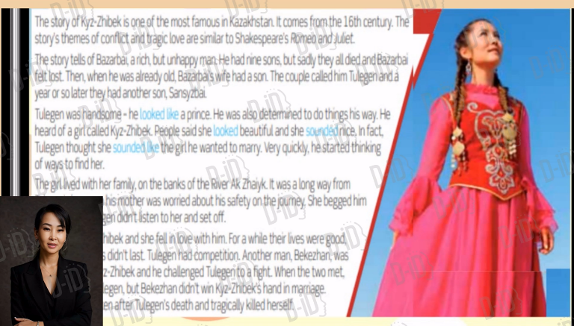  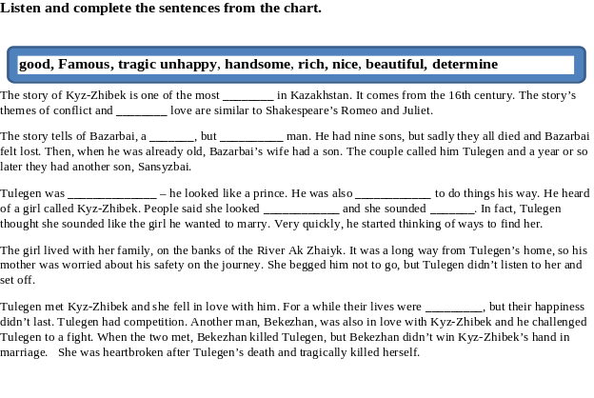  Task 2  Read the text about Kyz-Zhibek p 88  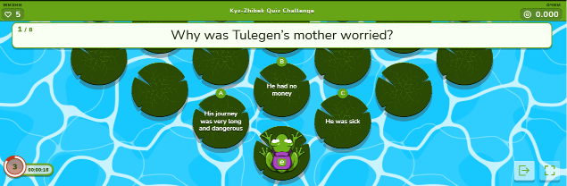  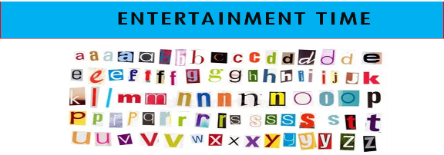  Task 3  Speaking  Individual work  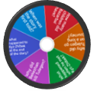  Task 4  Pair work  Exercise 3  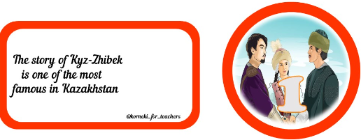  Task 4  Writing  Group work  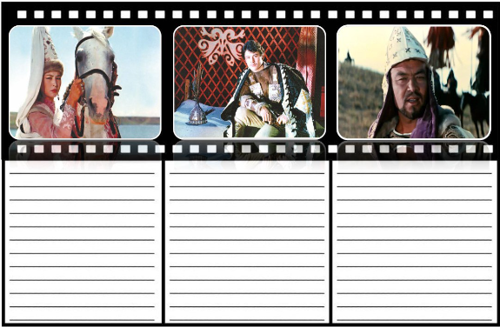  Assessment  Feedback  Home work: What is your favorite character? Write about it and present it to class.    Say Good bye | Descriptor:  - Choose one a wrapped paper and open it, read and write it on the blackboard  - Listen and repeat after the teacher  - Learn by heart the new words by the method of `SUITCASE`  Descriptor:  -listen to the text  and complete the sentences with adjectives from the chart  by the method of «AI»  Answers: Famous, tragic, rich, unhappy, handsome, determined, beautiful, nice, good,  Descriptor:  -go for a link  -read the questions and choose the suitable option on a platform ‘EDUCAPLAY’ by the method of ‘BREAK A BRAIN’  Descriptor:  -take letters to make sentences by the help of straws  n Descriptor:  -  Descriptor:  -go for a link  -spin the wheel and answer the questions on a platform ‘WORDWALL’ by the method of ‘BRAIN ATTACK’  Descriptor:  -read the sentences in cards  -put them in a right order according to the text by the method of ‘THINK TOGETHER’ ‘THINK  TOGETHER’  Descriptor:  -look at the pictures  -complete the graphic organizer with the describing these characters by the ‘THINK, FIND and SEEK’ 2 points  Write down on diary  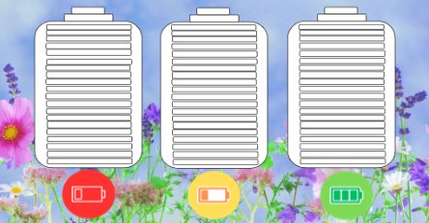  Children say Good bye | By the method of “COMPLIMENTS”  ‘well done’  ‘good job’  ‘wonderful’  Assessment: Pupils are evaluated by collecting points  Total: 2 points  Assessment:  Total: 2 points  By the method of “COMPLIMENTS”  ‘well done’  ‘good job’  ‘wonderful’  Assessment:  Total: 2 points  Assessment:  Total: 2 points  Assessment:  Total: 2 points | a wrapped paper  Interactive  White boards  Cards  https://www.educaplay.com/learning-resources/22537950 kyz_zhibek_quiz_challenge.html  straws  and letters  Interactive whiteboard  https://wordwall.net/ru/resource/87173875  Cards  Postcards  Assessment chart  