Санкеш Жаннұр Ерболатқызы
Ақтөбе облысы Темір ауданы «Сарыкөл жалпы орта білім беретін мектебі» ағылшын тілі пәнінің мұғалімі

Date: 26.04.2018
Grade: 8
The theme: William Shakespeare’s life and literature
The aims:
1. To give introduction about great play writer William Shakespeare’s life and works
2. To develop pupils interesting to extra curriculum works about famous people

Organization moment
1. Greeting
Good morning, boys and girls. I’m glad to see you. Today we have demonstrative lesson. Let’s start our lesson with training.
Dividing into three groups
Training “Me and my future”
2. Check-up hometask
Okey, who is ready? Who wants to begin? Your home task was retelling the text about life and literature of Abai Kunanbayev.
3. New lesson
Well! Before you start to know about our new lesson look at the blackboard! You see here a picture. Write the words which are you find. Please, one by one.
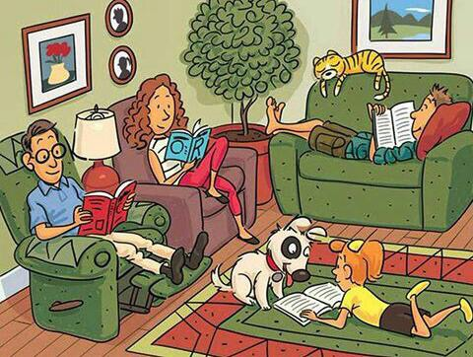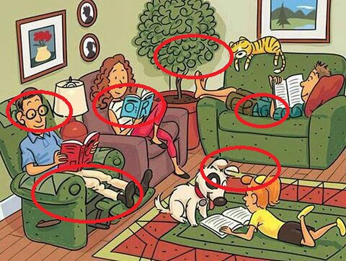
Yea, you are right. Today we are going to speak about one of the greatest English poets William Shakespeare’s life and literature. It is impossible to speak about the English literature without speaking about this author. He was the man who had the largest and most comprehensive soul. People all over the world can’t help admiring his great talent. William Shakespeare… The brilliant poet, the marvelous dramatist, the greatest of the great. He was not of an age, but for all time. W. Shakespeare – immortal poet of nature.
His name is William Shakespeare. People say he is world's greatest poet and dramatist. He was born on April 23, 1564 in Stratford-upon-Avon and he died also this date, April23, 1616 . His mother, Mary Arden, was a daughter of Robert Arden, a farmer. His father, John Shakespeare, was a glover who had an office at Stratford-upon-Avon.
He got his education at the Grammar School. He got married in 1582 to Anne Hathaway and had three children, a daughter and two sons.
They lived in Stratford. At that time actors and actresses visited Stratford-on-Avon. He liked to watch them. He was fond of their profession and decided to become an actor. Then he went to London. There he became an actor and began to write plays too. He worked in the modern theatre “Globe”. 14 years later he became a part owner of the Globe theatre in London.
The public theatres for which he wrote plays were quite different from those of today. They were built of wood
He wrote 37 plays altogether. Among plays there are historical dramas, comedies, great tragedies, romantic dreams. He is also known as the author of 2 long poems and 154 sonnets.
4. Conclusion
«Fish bone» strategy
The first task is to guess whether it is true or false. I’ll read some sentences about our guest’s life and you must choose (T) or (F).
William Shakespeare was born on April 23, 1564 and he died also this date, April23, 1616.(T)
His mother was a daughter of the farmer. (T)
W. Shakespe are married when he was 18 years old. (T)
He had 5 children: three daughter and twin sons. (F)
In the 16th century there were many theatres in Britain. (F)
Globe Theatre was built of wood. (T)
Nowadays Shakespeare’s Globe Theatre is opened all year round. (F)
W.Shakespeare wrote 57 plays. (F)

I’ll read some of Shakespeare’s quotations in English and you must match them and their translations.
1“Something is rotten in the state of Denmark”
2“To be or not to be”.
3“Sweets to the sweet”
4“Life is not all cakes and ale”
5“Love is blind”
6“The beginning of the end.”
7“All is well that ends well.
8“Brevity is the soul of wit”
9“Much ado about nothing.”
10“The whirling of time”
11“Cowards die many times before their death”
«Cinquain» strategy
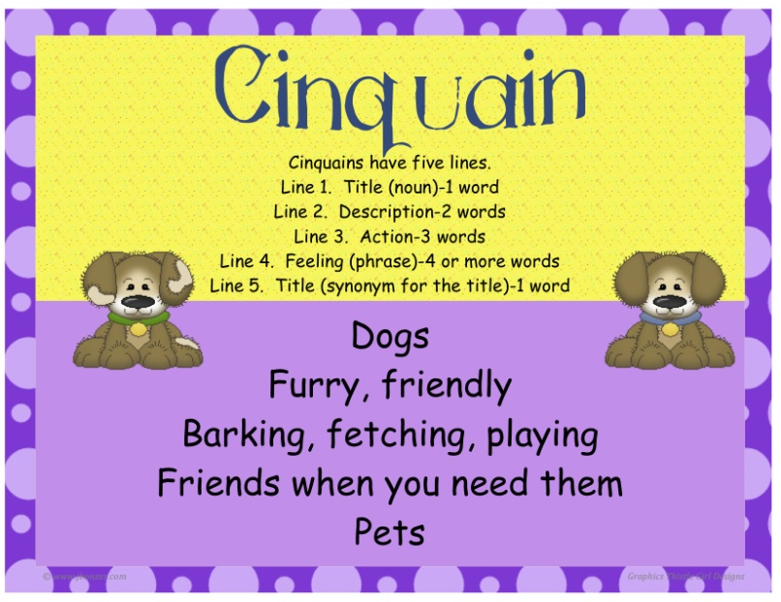
5. Бағалау
Reflection “Stairs of success”

Dear friends, thank you for the lesson. You have learnt a lot of things about Shakespeare’s family, about his native town, about his great works. I think it was very interesting and you will remember our lesson for a long time. Shakespeare was a great poet. He was “for all time”. I can give you some lists with Shakespeare’s quotations if you want and hope you’ll use them in your everyday speech. You have worked well today. Your marks at the lesson are...The lesson is over. Good-bye .
Marking
