ДОЖЖО
Тексерілді: _______________________ Патаева А

Long-term plan unit: Unit 6. Traditions and folklore |  |  |  |  | School: №1
Date 15.02.18 |  |  |  |  | Teacher name: Mirzalieva G
Grade: 2 “B” |  |  |  |  | Number present: |  | absent:
Theme of the lesson |  |  |  |  | Home cooking
Learning objectives(s) that this lesson is contributing to |  | 2.S3. use a limited range of basic words, phrases and short sentences to describe objects, activities and classroom routines  2. L9 Recognize the spoken form of familiar words and expressions  2.R1 Read and spell out words for others
Lesson objectives |  | All learners will be able to:  Understand the spoken form of familiar words and expressions  Most learners will be able to:  Read and understand the short words  Some learners will be able to:  To give an opinion to describe some objects
Success criteria |  | - Read words  - Spell out words for others  - Identify familiar words and expressions  - Talk about objects, activities  - Apply topical vocabulary, phrases and short sentences
Value links |  | To love their country, traditional food and to respect each other
Cross curricular links |  | Russian, Kazakh, Math, Art, PE
ICT skills |  | Lab top, white board
Previous learning |  | They know the names of some fruit. and read short words
Level of thinking skill |  | Knowledge-comprehension, Application
Plan
Planned timings | Planned activities |  |  |  |  |  |  | Resources  Visual aids:
Beginning  5minutes | Organization moment  Good afternoon!  Hello, how are you?  What is the weather like today?  Teacher will invite Ss to stand in a circle and to great each other, they smile each other  Join into two groups which called apple and banana  Lead- in  (W) Teacher shows images of traditional Kazakh food and asks learners: ‘What’s in it?’What can you see in this picture?  What will be our theme for today?  Pre-learning  (D) Teacher pre-teaches and revises basic food words  milk, cheese, eggs, fish, meat, flour, rice, sugar, tea etc. |  |  |  |  |  |  | Pictures of apple and banana  pictures of Kazakh traditional food  Flashcards
Middle  “A fantastic basket”  10min  “Word bank”  5minutes  5 minutes  Warm up  3 minutes  7minutes | Task L9.  (G)Stick the pictures onto the poster. Listen to the teacher and colour them. (Peer assessment)  Stick two apples and colour them in red.  Stick the banana and colour it in yellow.  Stick the grapes and colour them in purple.  Stick two eggs and colour them in orange.  Stick the milk and colour it in blue.  Stick the juice and colour it in orange.  Descriptor: A learner  Makes the poster  Sticks the pictures  Colors the pictures  R1.Task (I) differentiation  Read the sentence and spell the underlined word.  More able learners:  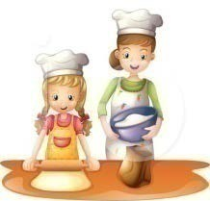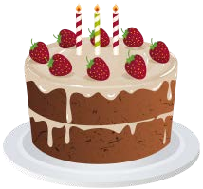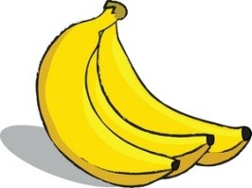Bake a cake.  Peel the banana  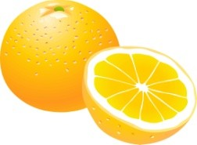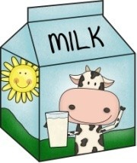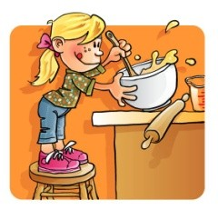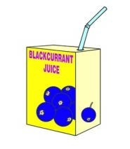Cut the orange.  Beat eggs.  Add some milk.  Drink juice  Eat pizza.  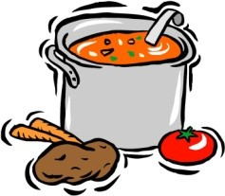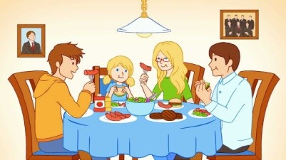Cook soup.  Enjoy your meal.  Less able learners:  Milk, eggs, banana, cake  Descriptor A learner  - reads the words appropriately;  names the letters of the underlined words  L9. (I)Task (Self assessment)  Listen to the teacher and put a tick ✓ in the box next to the right picture  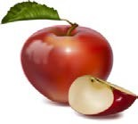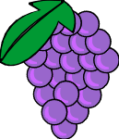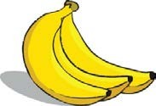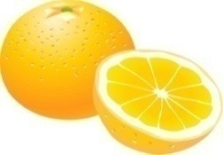  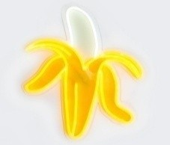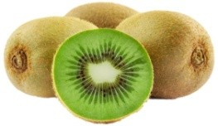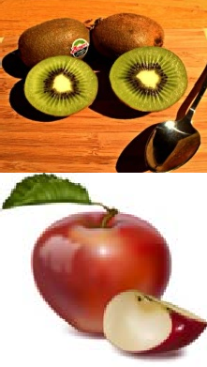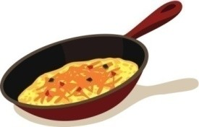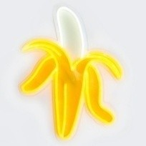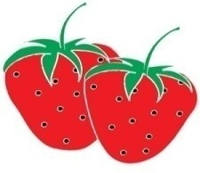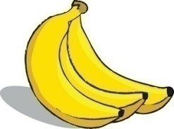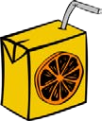  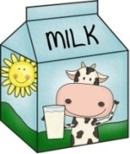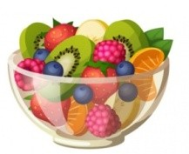 |  |  |  |  |  |  | Pictures, posters, colored pencils  Worksheets  Worksheets  Cubic
  Descriptor  Hands up ,  Task | A learner  - marks the pictures correctly
  S3. Make up | the sentences to describe objects.  I can cook soup.  My mother can cook fish.  My brother can cook pizza.  My sister can cook cake.  Descriptor: A learner  - Makes up the short sentences
End  “Fly swatter”  5 minutes | Plenary  Task.  Listen to your partner and beat the words.  Apple, sugar, cake, rice, banana, tomato, fish, cheese, salad, pop corn, milk, flour  Descriptor: A learner  - Finds the correct word  Take their reflections  To show their thumb up and down |  |  |  |  |  |  | Pictures, fly swatter
Additional information
Differentiation – how do you plan to give more support? How do you plan to challenge the more able learners  the will be |  |  | Assessment – how are you planning to check learners’ learning? |  |  | Health and safety check  ICT links
More able learners read words and spell it  Less able learners read the words |  |  | Fact-based observation  Self-assessment  Peer assessment |  |  | Careful movement around the room  Boy-girl-boy-girl arrangement within sitting and standing circles to encourage positive behavior like keeping hands to self.
Reflection
Were the lesson objectives/learning objectives realistic?

What did the learners learn today?

What was the learning atmosphere like?

Did my planned differentiation work well?

Did I stick to timings? What changes did I make from my plan and why?
Summary evaluation

What two things went really well (consider both teaching and learning)?
1:
2:

What two things would have improved the lesson (consider both teaching and learning)?
1:
2:

What have I learned from this lesson about the class or individuals that will inform

my next lesson?

